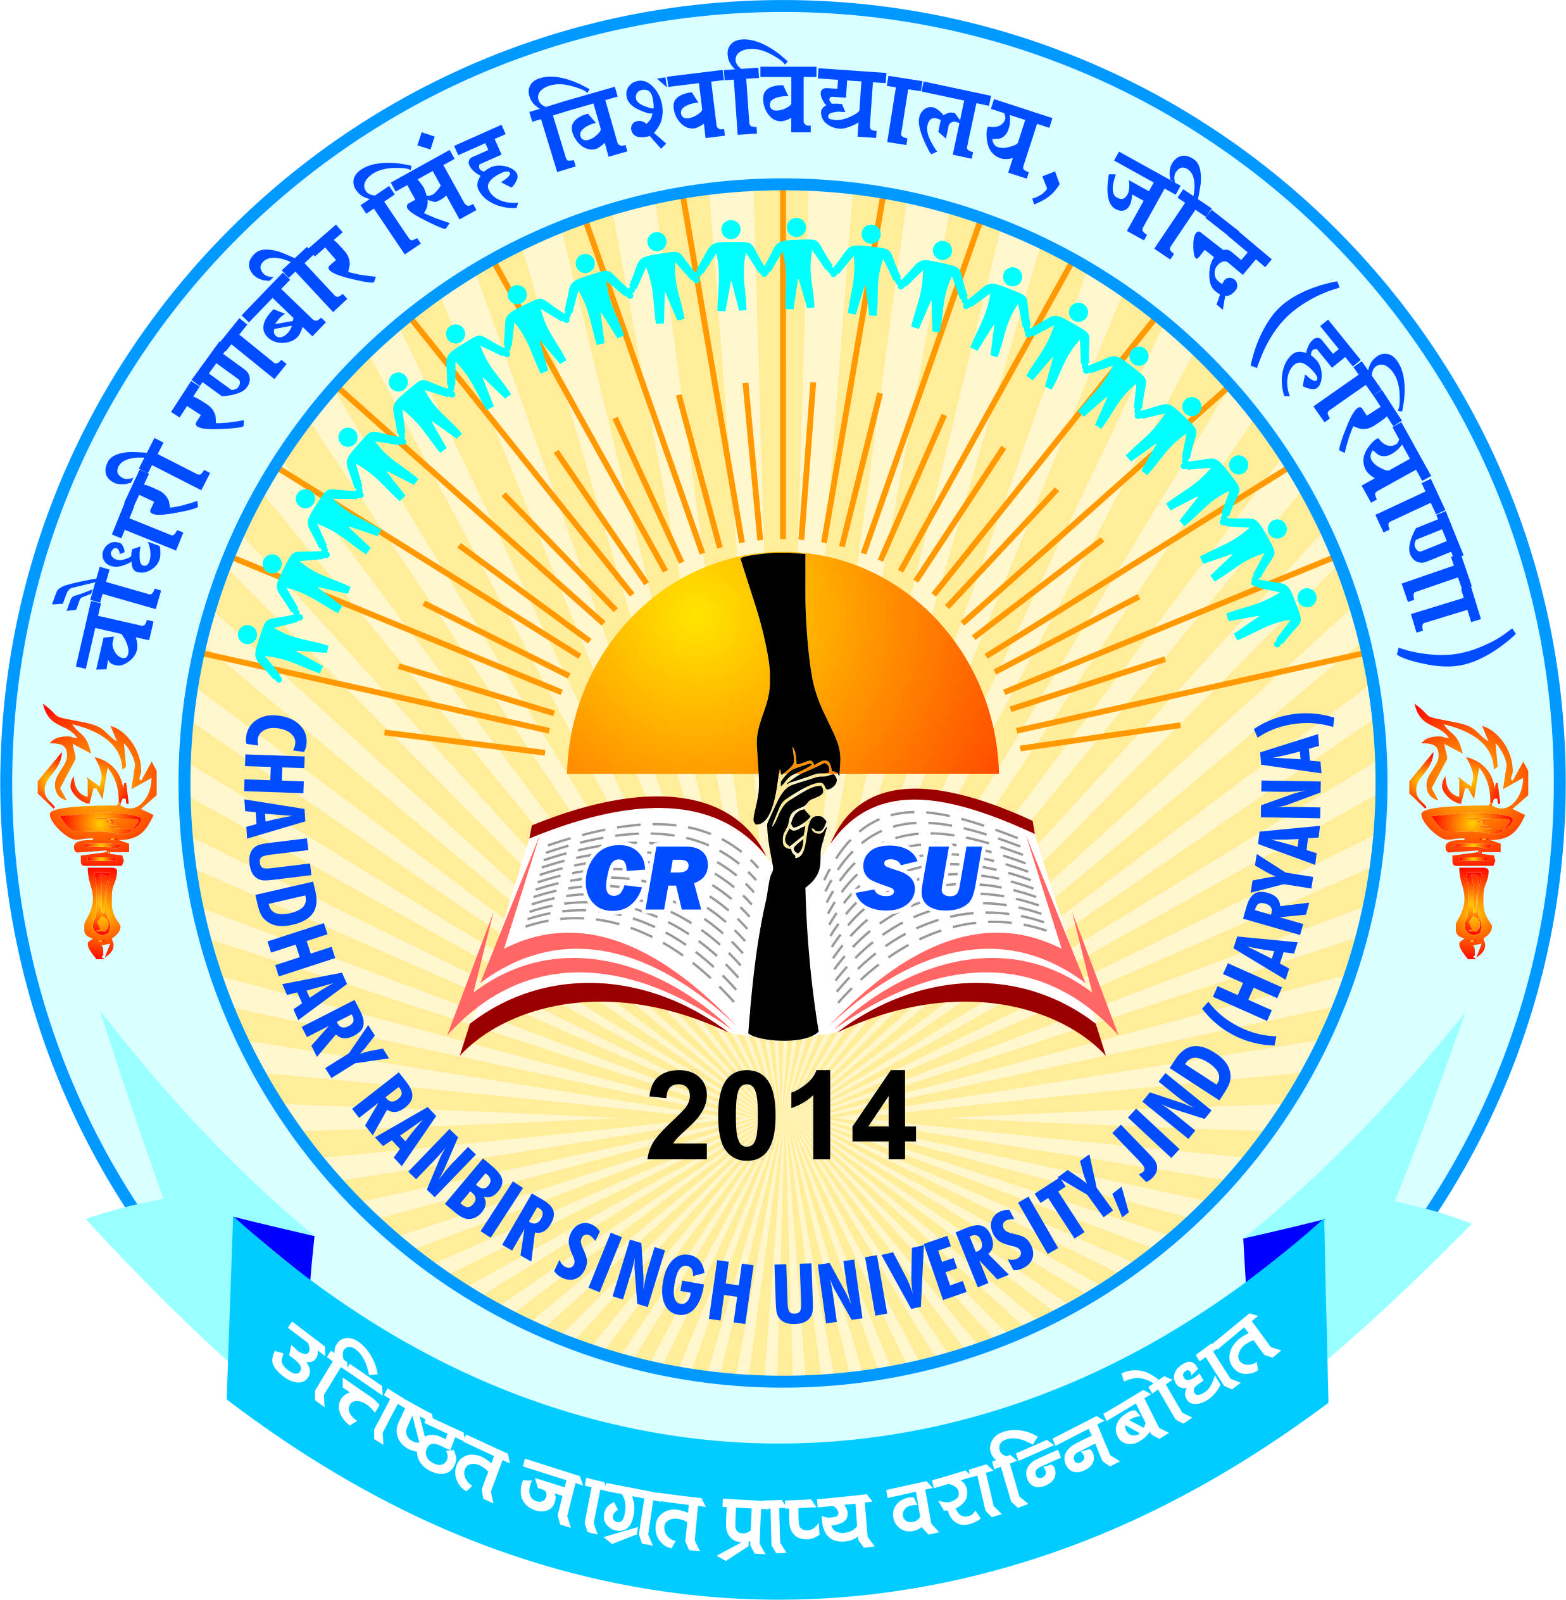 | pkS/kjh j.kchj flag fo'ofo|ky;]thUn  Chaudhary Ranbir Singh University, Jind  (Established by the State Legislature Act 28 of 2014) | 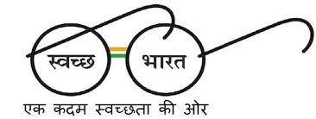

NOTICE

ADMISSION SCHEDULE OF PHYSICAL COUNSELING FOR VACANT/ADDITIONAL/ SUPERNUMERARY SEATS FOR ADMISSION TO VARIOUS COURSES 2017-18
It is notified that the physical counseling for admissions to following courses being run in the University will be carried out by the respective Department as per schedule given below:
Name of Course | Date & Time of reporting of candidates for physical counseling | Date & time for display of merit list | Fee/dues depositing up to | Venue
MCA, M.A. (Education), M.A.(Music –Vocal & Instrumental), B.P.Ed.  P.G. Dip. in Yoga, M.A. (Yoga), M.Tech (CSE) | 31.07.2017  09.00 a.m. to 11.00 a.m. | 31.07.2017  at 12.30 p.m. | 31.07.2017 upto 4.00 p.m | In the concerned Department at CRSU, Jind
Freshers need to apply manually by filling the application form and fee Rs.500/- (Rs.125/-for SC/BC/Blind candidates of Haryana) on the spot. All the aspirants to report in the concerned department on 31st July 2017 upto 11:00 a.m. First preference will be given to those candidates who have already applied online. If seats remain vacant, then only fresher will be given the chance.
For more details visit www.crsu.ac.in

Registrar

